Half-Termly Curriculum Overview for Year 5 Autumn Term November/December 2025
Mrs Bahi & Mr Boutflour



English Kensuke’s Kingdom by Michael Morpurgo
Outcomes: Children will be able to:
Explore features of an adventure story.
Empathise with characters, explaining their behaviour and feelings.
Act out the roles of different characters in the novel.
Discuss words and phrases that capture readers’ interest and imagination.
Use dialogue to advance the action.
Write a diary entry in role.
Write their own adventure story.

Maths Multiplication & Division
Outcomes: Children will be able to:
Count in 6s, 7s, and 9s.
Recall multiplication and division facts for multiplication tables to 9.
Use knowledge of place value, multiplication and division facts to
multiply and divide numbers mentally
Recognise the relationship between multiplication and division
Use written methods to multiply 2 or 3 digit numbers by a 1 digit number.
Answer word problems using multiplication and division

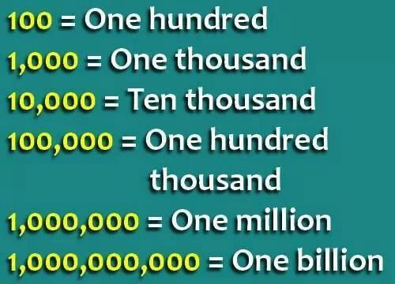
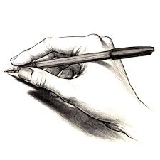

Topic- World War 2
Topic
Our topic is “World War 2”.

In this topic they learn about a range of topics. Some of which include:
When and why WW2 started.
A timeline of key events
Rationing
Map work on the countries involved
Women in the war
Propaganda
Dunkirk

Religious Education
How do Christians advertise Christmas?
Outcomes: Children will:
Investigating the meanings of advertisements
Looking at the versions of the Nativity story in the bible
How and why does the church advertise Christmas
Designing an advertisement for a local church

PHSE – Celebrating Differences
Outcomes:
Understanding there are different perception of ‘normal’.
Having empathy for others.

Our topic is for the whole of the Autumn Term is World War 2
We will learn about lots of different aspects but these are some key areas:
Key leaders
Propaganda
Dunkirk
How and why America joined the War
How the war ended
A visit to the war memorial in Bethnal Green
A visit to the Imperial War Museum in London

Physical Education – Monday & Friday
To learn how to work in pairs/groups
This half term we will focus on Dance and Handball for the two sessions.

Please bring your PE Kit on a Wednesday and swimming costume on Friday

Computing
We will be looking at online safety including SPAM and also spreadsheets.

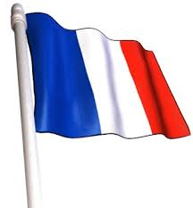
Science – Staying Alive

We will learn about the circulatory system, and what blood is made up of.
We will learn about the effects of exercise on the body
We will be able to explain the effects of smoking, drugs and alcohol on the body.
We will be able to look at a range of data and interpret it.

The effects of exercise
The benefits of a healthy diet

Music - Shadows
Our class will continue to learn a repertoire of songs with their work with Mr Cook from the St Paul’s Cathedral Choral Programme.
French
We will learn how to converse in
basic French about shopping.

Parents How Can You Help
Which party do you support and why?
Reading: Children are expected to read every night and/or complete their Guided Reading task, which is usually a short-written task. They must bring their book into school every day.
Homework: Children will receive homework for Maths, English, Topic and Spelling every Friday via Purple Mash, and it should be handed in electronically by Wednesday of the following week.

Timetables: Please encourage your child to learn their tables. Remind them to use Timetables Rock Stars.

